Social Studies 8
Section: Writing Skills
Lesson: Paragraph Writing
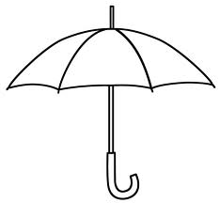
SUPPORTING DETAILS
- ______________
- ______________
- ______________
- ______________
TOPIC SENTENCE
CONCLUDING SENTENCE

- Paragraphs are like an UMBRELLA

  - All relavant points come under the umbrella

  - Anything that doesn’t belong gets wet

Social Studies 8
Section: Writing Skills
Lesson: Paragraph Writing

- ______________
2.______________
3.______________
4______________

- _______________________________________

  - ____________________________________

  - ____________________________________

